iTWIST Navigation Map for Searching and Reading

Division of Protection and Permanency

TWIST is still a unified system; however, beginning January 21, 2014, TWIST intake and assessment functions are moving to an internet based platform (iTWIST). This change is the first step to migrating the entire system to a more modern, web-based system. Ongoing functions (case plans, service recordings) will remain in their current platform (in this document, referred to as cTWIST). The login and navigation of the current TWIST platform, for the most part, unchanged. The following tip sheet contains information for both internal/external TWIST users who read, but do not enter information into, TWIST. Content is laid out as follows:

1. Logging On
   1. Internal (CHFS network) Users
2. Orientation to iTWIST Screens/Tabs/Progress Bar Contents
3. Finding Case Information
   1. Identifying the Individual
   2. Identifying Individual/Case Associations
   3. Identifying Case Management (County/Personnel by Assignment)
4. Reading Case Content
   1. cTWIST & “Reports”
   2. iTWIST, Pending Intakes
   3. iTWIST, Approved Intakes, Pending or Approved Investigations
5. Notes

# 1. Logging On

## a. Internal (CHFS Network Users):

cTWIST: To access cTWIST you will continue to use the **Citrix Twist** icon on your desktop.

iTWIST: To access iTWIST the user will open internet explorer and type <https://kog.chfs.ky.gov/home/> in the address field.

When you click on iTWIST this will open to the iTWIST home page.



# 2. Orientation to iTWIST Screens

On the iTWIST home page, the navigational menu at the top provides the screens available in iTWIST.

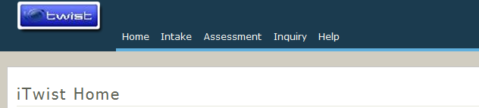

“Home” will return the user to this home screen from anywhere in the web-based screens.

“Intake” is for use by centralized intake personnel, supervisor approvals of intake decisions, or by persons searching for an intake in progress. The search function replaces and replicates the function of the hotline search previously available in cTWIST.

“Assessments” is for use by workers completing assigned investigations/assessments, supervisors approving extensions or approving investigations/assessments, persons amending investigations/assessments by court order or through the administrative hearing process, or persons searching for investigations/assessments.

“Inquiry” permits a user to search by case number or individual.

“Reports” permits a user to search for reports by case number.

# 3. Finding Case Information

## a. Identifying an Individual:

When working from an individual name or social security number, a comprehensive search of that individual can be executed from the inquiry search in iTWIST or by searching for the individual in cTWIST.

iTWIST

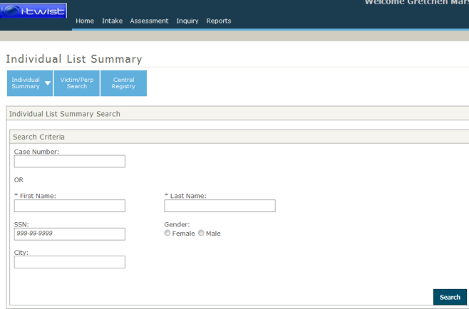

cTWIST

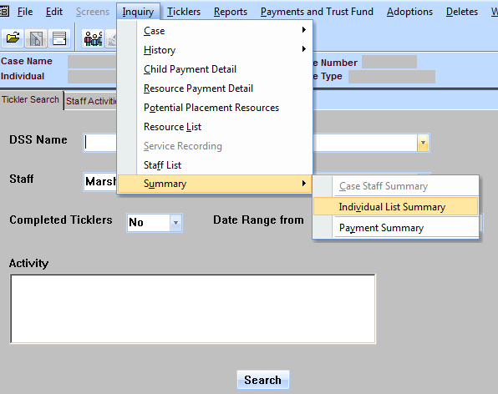 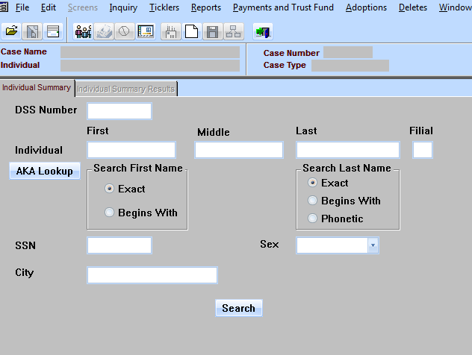

cTWIST searches will provide results in the same format as before.

iTWIST searches will provide results below the search fields on the same screen. Search result columns include, date of birth, gender, social security number, case number and case manager.

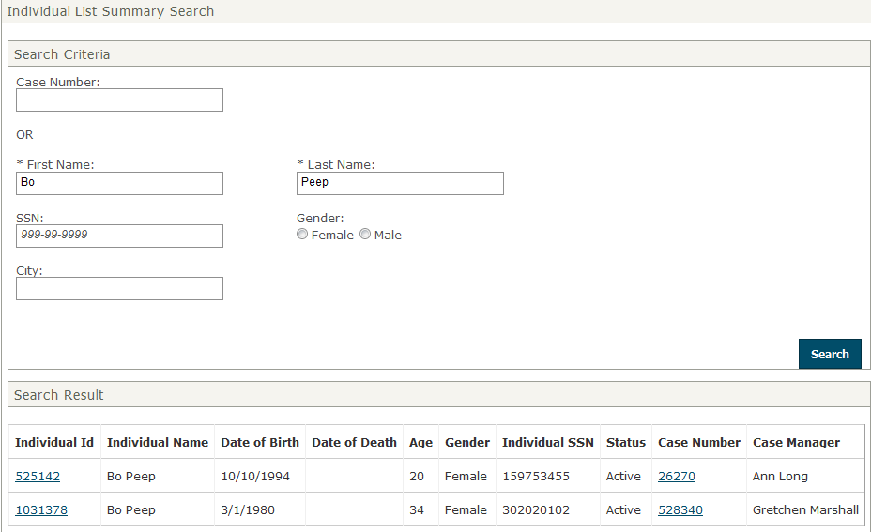

Once you identify the correct individual and case association make a note of the case number to:

* Navigate, search for and read investigations in iTWIST screens
* Open cTWIST to search for and open ongoing case work related to that case.

## b. Identifying Individual/Case Associations:

“Individual ID”

Following a search, clicking the “Individual ID” (circled above) will provide a pdf file, the “Individual Summary Face Sheet.” The pdf file can be maximized, printed or saved using the pdf menu and controls. The face sheet provides a summary of case history associated with that individual. The face sheet will indicate the allegations/results of prior investigations/assessments, indicate prior open cases and closures (if applicable), provide placement history (if applicable). The summary sheet will also identify the county of responsibility for the ongoing case. An example of the face sheet is provided with this tip sheet.

Note that the individual summary will bring information for any case/multiple cases, for cases that includes the individual.

“Case Number”

Following a search, clicking the “Case Number” (circled above) will provide a pdf file, the “Case Summary Face Sheet.” The pdf file can be maximized, printed or saved using the pdf menu and controls. The case summary face sheet provides a list of all case individuals, indicates the allegations/results of prior investigations/assessments, indicates openings/closures of the case (if applicable), any placement history (if applicable). An example of the case summary face sheet is provided with this tip sheet.

Note that the case number is displaying information specific to the case, and those individuals within the case.

## c. Identifying Case Management (County/Personnel by Assignment):

Both the individual summary and case summary face sheets identify county of responsibility for an open case.

The case history of assignment is also still available in cTWIST from the inquiry menu:

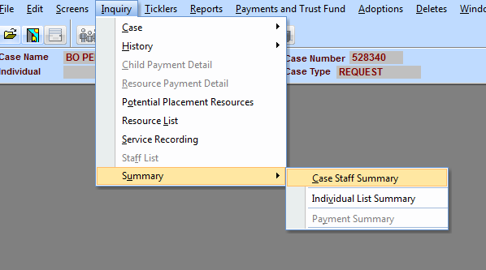 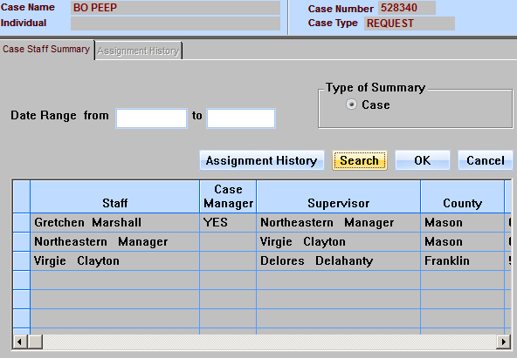

# 4. Reading Case Content

## a. cTWIST & “Reports”:

Once a TWIST user opens a case in cTWIST, most content (except from the intake or a pending investigation) can be viewed from there.

All ongoing content is under the same menu options as before.

Approved investigative assessments can be viewed under “Reports.”

## b. iTWIST, Pending Intakes:

A TWIST user may open a pending intake by searching the intakes screen.

The function works exactly as the hotline search function.

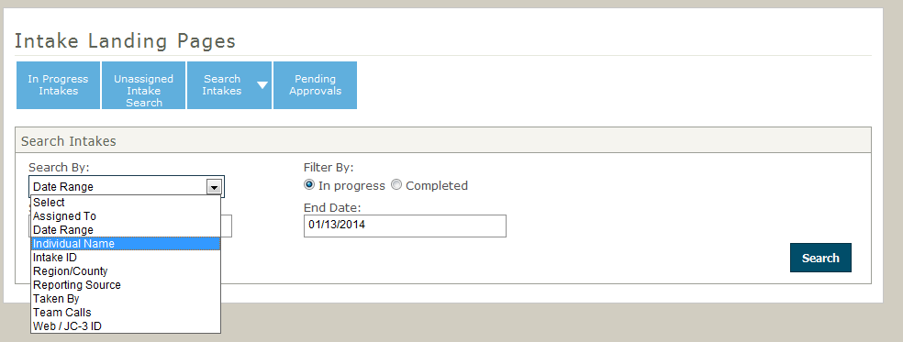

A reader can select the “Intake ID” to read the pending intake screens directly.

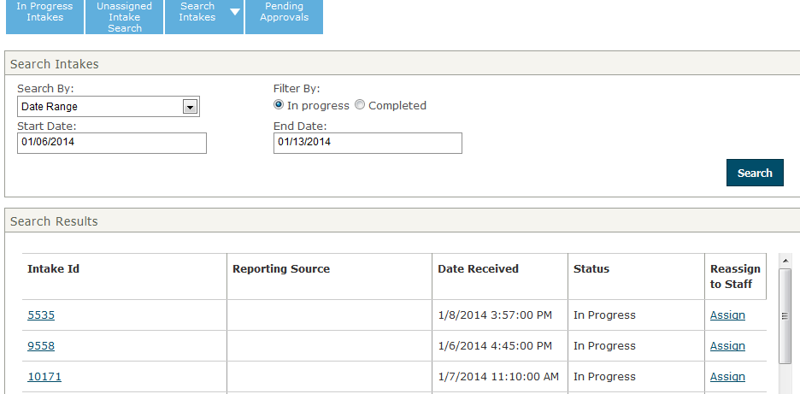

## c. iTWIST, Approved Intakes, Pending or Approved Investigations

A TWIST user may open any investigation by searching for the case number or intake id from the assessment function:

i: 

ii: 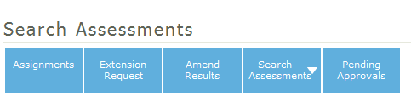

iii. 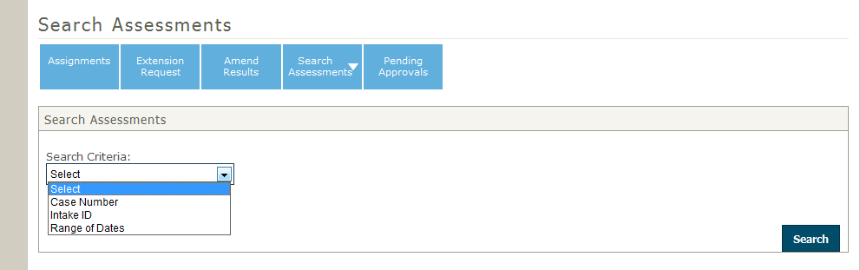

iv. 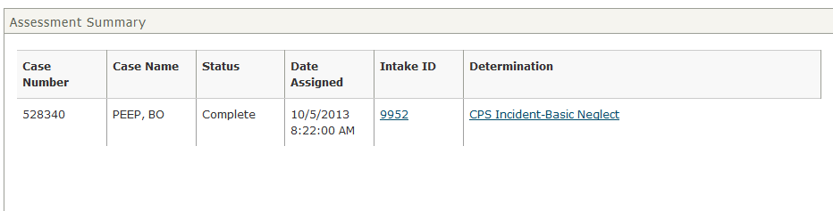

Clicking “Intake ID” will open a pdf of the approved intake.

Clicking the incident in the “Determination” column will open a pdf of the completed investigation. If the investigation is complete, it will open the assessment screens to view the incomplete assessment as it was last saved.

# 5. Notes

* FINSA is now a finding—not an assessment path. At intake, centralized intake staff will determine if a report contains allegations or not. If a report does contain allegations, they will determine if the allegation meets criteria for a protective services investigation/assessment or not.
* At the conclusion of an investigation that met criteria for a protective service assessment, the worker will enter whether or not the case was unable to locate, the findings were substantiated, the findings were unsubstantiated, the family is in need of services, or the family is not in need of services.
* There are multiple new assessment paths for assignments that do not contain child welfare allegations, including safe infant cases, foster parent recruitment assessments, court ordered assessments and out of state requests for assistance.
* After launch, report any issues to the help desk. There will be bugs. There will also be things that you want to see enhanced. Once those issues are identified, the work team will identify those things that do require a work request. We’ll prioritize them from most urgent to less urgent, and schedule releases to fill those work requests.