- To register for the first time with the electronic AOC registry, go to http://kcoj.kycourts.net/PublicMenu/Register.aspx and complete the fields listed below.
- When finished, click the “Register” button at the bottom of the page.
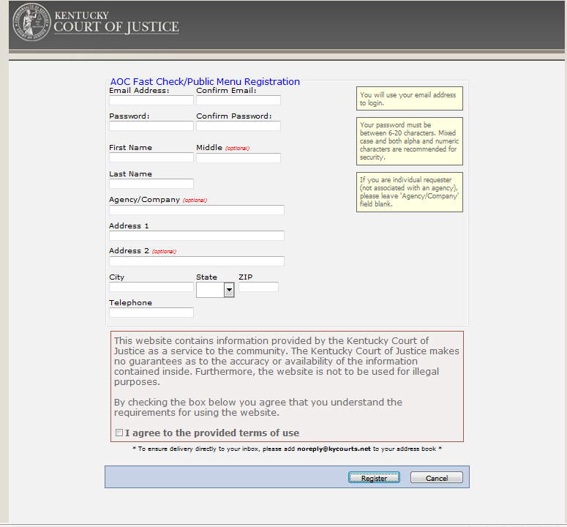

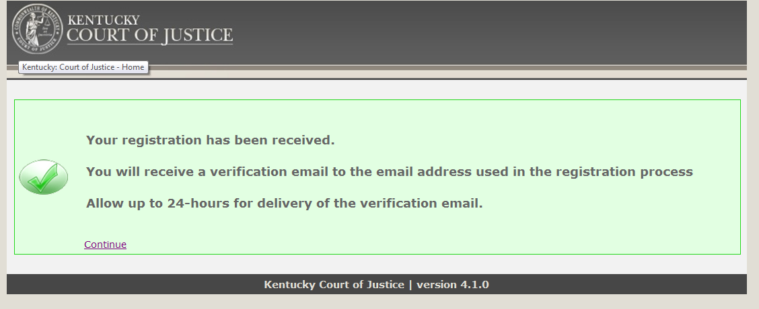
- You will receive the following message. Click the “Continue” button at the bottom of the box.

- Shortly after, you will receive an e-mail sent to the address you entered into the AOC Fast Check/Public Menu Registration page.
- The e-mail you receive will have a link embedded in it. You must click on that that link in order to activate your account. After you click the link, you will receive the following message.
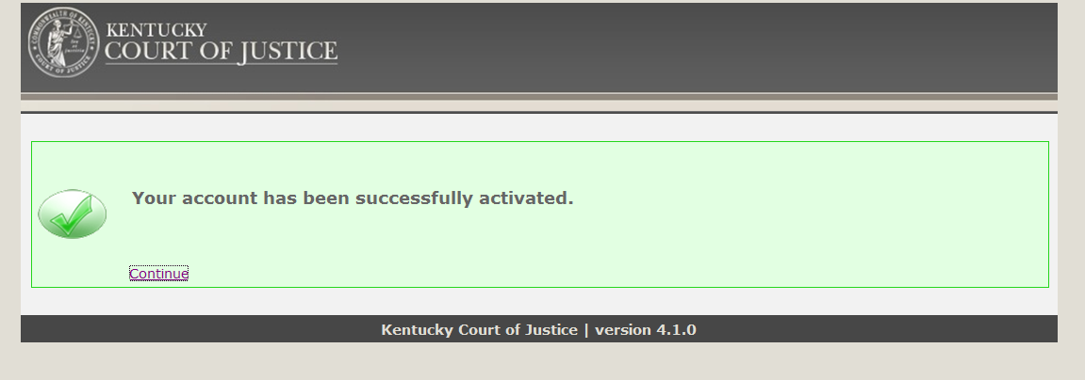

- Click “Continue” and you will be taken to the following page.
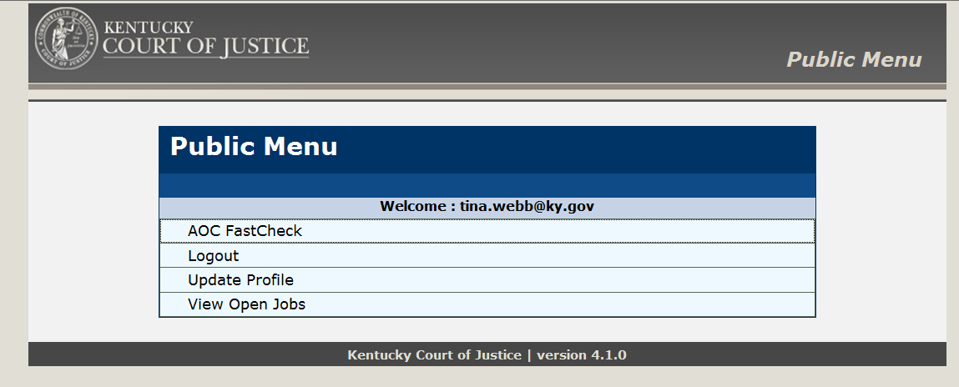

- Click the “AOC FastCheck” link above.
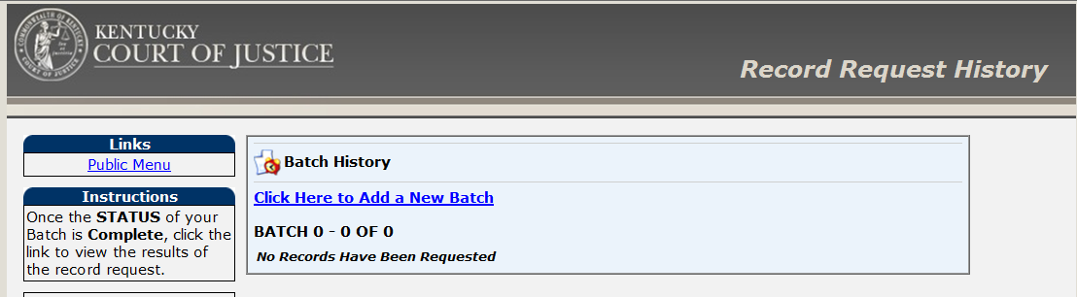

- After clicking on the fast check link, you will be routed to the page above. Click on “Click Here to Add a New Batch” to continue on to the area where you will enter the type of AOC check needed.
- Once on the “Request Type Information” page, choose the “Category” and “Group” selection, from the drop down boxes, that meet the needs of the AOC check request.
  - CHFS – Imminent Risk Investigation should appear like this:
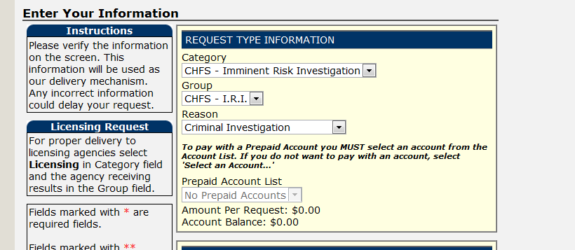

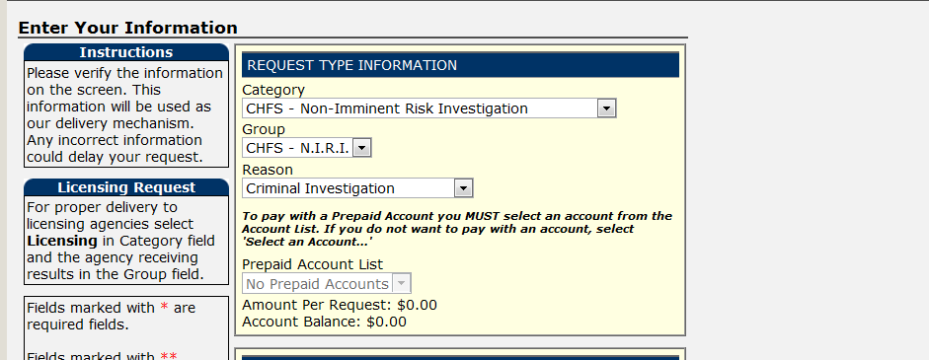
  - CHFS – Non-Imminent Risk Investigation should appear like this:

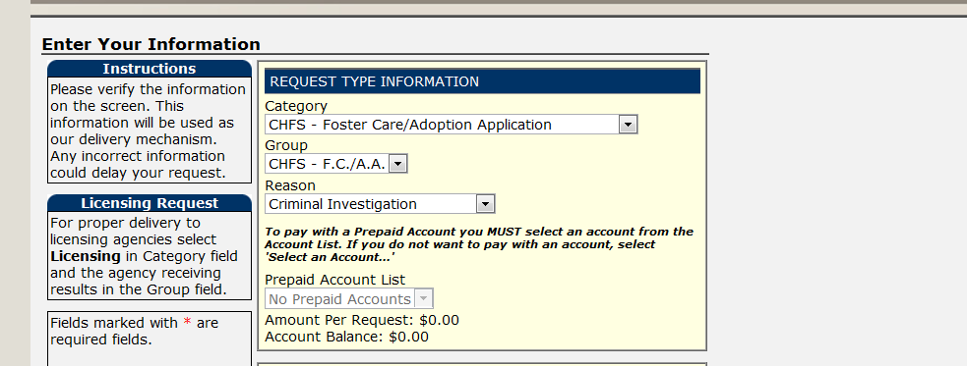
  - CHFS – Foster Care/Adoption Application should appear like this:

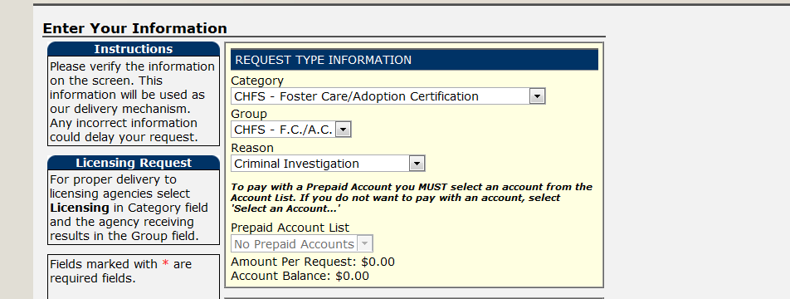
  - CHFS – Foster Care/Adoption Certification should appear like this:

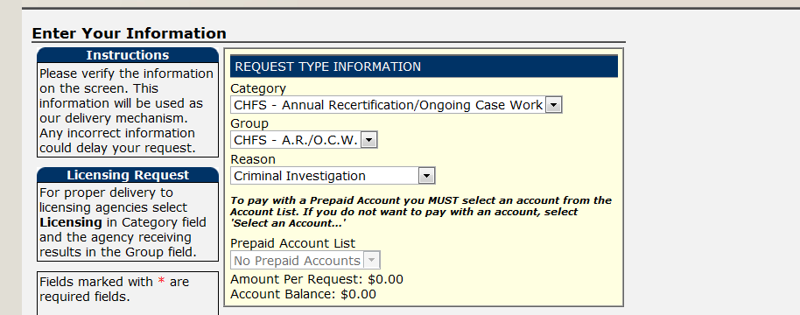
  - CHFS – Annual Recertification/Ongoing Case Work should appear like this:

