

11

**DPP-103 Application for Tuition Assistance Guide**

**For Social Workers with Youth Enrolling and/or Attending College**

**Contents**

**Introduction……………………………………………………………………………………………………………………………….. 3**

**Policy………………………………………………………………………………………………………………………………………. 4-5**

**Step 1: Completion of Financial Aid Paperwork & Gathering of Financial Aid Resources**

**FAFSA……………………………………………………………………………………………………………………………….6**

**Tuition Waiver…………………………………………………….……………………………………………………………7**

**Online Student Accounts…………………………………………………………………………………………………..8**

**Sample Online Student Bill……………………………………………………………………………………………….9**

**Step 2: Completion of Application for Tuition Assistance**

**DPP-103 Application………………………………………………………………………………………………..……….10**

**Deficit Example…………………………………………………………………………………………………………………11**

**Sample letter to Bursar’s Office………………………………………………………………………………………..12**

**Surplus Example………………………………………………………………………………………………………..……..13**

**Step 3: Payment of Tuition Assistance Funds**

**Payment directly to youth…………………………………………………………………………………………………14**

**Payment to the college……………………………………………………………………………………………………..14**

**Introduction:**

The DPP-103 Application for Tuition Assistance Approval should **ONLY** be utilized as a last resort to pay for college expenses not covered by financial aid. It is extremely important that youth complete the **FAFSA** (*Free Application for Federal Student Aid*) and turn in a tuition waiver form in a timely manner so financial aid will be verified before classes begin each semester.

* Approval for the DPP-103 Application for Tuition Assistance should only be needed for youth attending a regional university and living in a dorm.
* If a youth is placed in a foster home or in a scattered site apartment living program, tuition assistance should not be needed due to all direct school expenses being covered by financial aid.
* If a youth is enrolled in summer classes approval may be needed to help pay for a youth’s books, summer housing (dorm room) and meal expenses. The tuition waiver should cover summer tuition expense. However, a youth can apply for summer financial aid which may make the tuition assistance unnecessary.
* Youth attending the community/technical college systems SHOULD NOT need tuition assistance if they completed the FAFSA in a timely manner and submitted the tuition waiver to the college.
* The tuition assistance application approval is only needed when a youth has a deficit, not a surplus. However, it is good idea to complete one when you are unsure if all school expenses will be paid.
* SRA approval is required on the tuition assistance application. Frankfort approval is not needed.
* Once approved, the original approval is given to the Regional Billing Specialist. If monthly payments to a youth are needed an email should be sent to the Regional Billing Specialist each month unless the youth is paid in one lump sum. If payment is made to the college, an invoice or statement is required along with a copy of the tuition assistance approval.

This guide breaks down the tuition assistance approval process into 3 steps:

**Step 1: Completion of Financial Aid Paperwork & Obtaining Financial Aid Resources**

**Step 2: Completion of DPP-103 Application for Tuition Assistance**

**Step 3: Payment of Tuition Assistance Funds**

**Policy on the DPP- 103 Application for Tuition Assistance:**

Policy on the DPP-103 Tuition Assistance Application can be found in the online policy manual in section **4.28.4 Higher Education Assistance** [http://manuals.sp.chfs.ky.gov/chapter4/12/Pages/4284HigherEducationAssistance.aspx](https://manuals.sp.chfs.ky.gov/chapter4/12/Pages/4284HigherEducationAssistance.aspx)

**DPP Application for Tuition Assistance**

[http://manuals.sp.chfs.ky.gov/Resources/sopFormsLibrary/DPP-103%20Application%20for%20Tuition%20Assistance%20for%20Youth%20Committed%20to%20CHFS-DCBS.doc](https://manuals.sp.chfs.ky.gov/Resources/sopFormsLibrary/DPP-103%20Application%20for%20Tuition%20Assistance%20for%20Youth%20Committed%20to%20CHFS-DCBS.doc)

**Tuition Waiver**

[http://manuals.sp.chfs.ky.gov/Resources/sopFormsLibrary/DPP-333%20Tuition%20Waiver%20for%20Foster%20and%20Adopted%20Children.doc](https://manuals.sp.chfs.ky.gov/Resources/Archived%20Documents/DPP-333%20Tuition%20Waiver%20for%20Foster%20and%20Adopted%20Children.doc)

### *Legal Authority/Introduction*

* [*922 KAR 1:450 Eligibility confirmation for tuition waiver*](http://www.lrc.state.ky.us/kar/922/001/450.htm)

### *Procedure*

***If the youth is eligible for a tuition waiver as established in KRS, KAR:***

1. *The SSW provides the youth with the* ***DPP-333 Tuition Waiver for Foster and Adopted Children****, which is presented to the post-secondary institution.*

***If the youth or adult is committed (includes extended or reinstated) the following steps apply to tuition assistance (not tuition waiver)    
The SSW:***

1. *Assists the student in selecting a post-secondary education institution and applying for all appropriate forms of financial assistance;*
2. *Or Independent Living Coordinator (ILC) is to assist the student with his request for tuition assistance from the Cabinet rather than waiting for grant and scholarship awards;*
3. *Completes the DPP-103 and submits it through supervisory channels to the SRA or designee for approval four (4) weeks before funds are needed.* [*1*](https://manuals.sp.chfs.ky.gov/chapter4/12/Pages/4284HigherEducationAssistance.aspx#fn)

***The Chafee Program Administrator in central office:***

1. *Returns the verified DPP-333, Tuition Waiver for Foster and Adopted Children to the requesting institution within thirty (30) working days of its receipt.*

### *Practice Guidance*

* *The post-secondary institution submits the DPP-333-Tuition Waiver for Foster and Adopted Children to central office and requests confirmation of the youth’s eligibility.*
* *Re-submittal of the DPP-333, Tuition Waiver for Foster and Adopted Children is necessary when the youth transfers to another public post-secondary institution in Kentucky.*
* *If the youth is determined by the Cabinet to be ineligible for a tuition waiver, he may request an administrative hearing.*
* *If the youth or adult is committed (includes extended or reinstated), the following steps apply to tuition assistance (not tuition waiver):* 
  + *Payment for clothing, incidental and allowance may be made in a lump sum for the semester or monthly payments to the student;*
  + *When the student will attend a school outside his home county, the SSW may refer the student to the ILC or appropriate FSOS located in the county where the student’s school is located. A copy of the approved DPP-103 may be attached to the referral letter. Specific services may be requested for the student.*

### *Footnotes*

1. *Separate requests should be submitted for each semester and summer session.*

**Step 1: Completion of Financial Aid Paperwork & Obtaining of Financial Aid Resources**

**FAFSA (*Free Application for Federal Student Aid*):**

All foster youth MUST complete the Free Application for Federal Student Aid (FAFSA) online at [www.fafsa.ed.gov](http://www.fafsa.ed.gov) in order to attend college. If a youth will be graduating in May, he/she needs to complete the FAFSA ASAP after January 1 each year. If a youth is expected to receive their GED/diploma in December or any other time of year, it is recommended to complete the FAFSA as soon as possible.

Below is a screen shot of the FAFSA website.

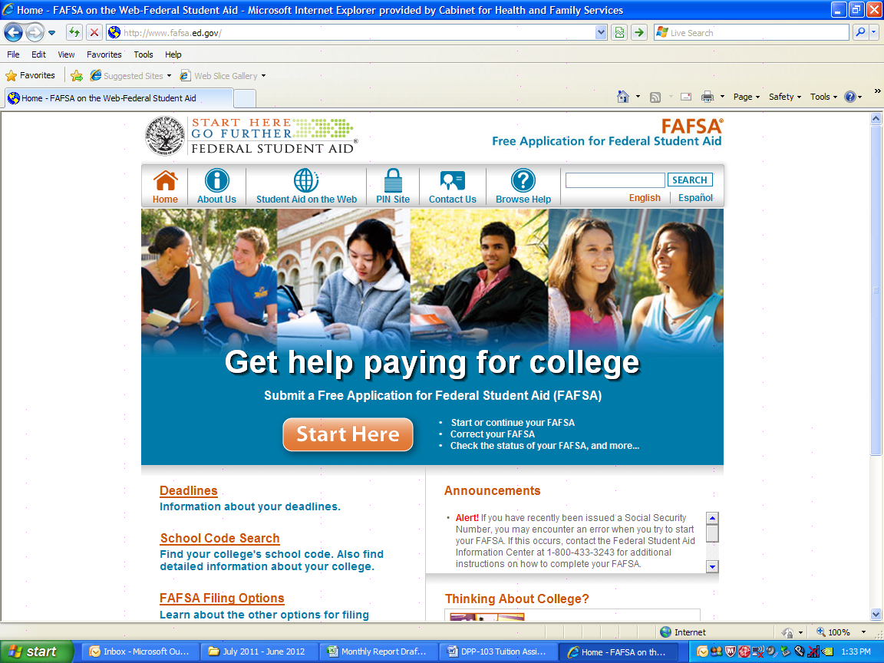

* Foster youth should be eligible for the maximum Federal **Pell Grant** of **$2,775**/semester and a **Kentucky CAP Grant** of **$950.00**/semester **IF** they submit their FAFSA early.
* If a youth is late in completing the FAFSA, they **WILL NOT** receive a CAP Grant because all of the grant monies will be allocated due to limited funds.
* If a youth has good grades in high school they are eligible for **KEES** money and may earn additional KEES from his/her ACT scores. KEES info. can be accessed at: <http://www.kheaa.com/website/kheaa/kees?main=1>
* A few weeks after completion of the FAFSA, youth should receive a SAR (Student Aid Report) which estimates the financial aid a youth is eligible for.
* Most foster youth get selected for the ***verification process*** due their marking “YES” on the following FAFSA question: “*At any time since you turned age 13, were both your parents deceased, were you in foster care or were you a dependent or ward of the court?”* This may require the social worker submitting proof of commitment such as a typed letter or copy of the commitment order be sent to the financial aid office.

**Tuition Waiver:**

**All foster youth MUST complete a Tuition Waiver and submit it to the college they will be attending.**

Youth completes section 1, submits to the college who completes section 2 and they should forward to Frankfort. Frankfort will send notification of approval or denial to the college.

It is recommended that the youth submit the waiver to the college after they have been accepted or immediately after they enroll in classes. **Each youth should make sure the tuition waiver has been applied to their student account prior to the beginning of each semester classes.** Some colleges may require submittal of the tuition waiver each semester.



Frankfort verifies youth eligibility & notifies the college

College completes Section 2, submits to Frankfort

Youth completes Section 1

**Online Student Accounts:**

In order to complete a DPP-103 Application for Tuition Assistance, it is important to have actual figures on the costs to attend a college and the financial aid resources a youth will be receiving for the semester. Youth should be able to access their online student account to check on billing statements, class schedules, grades, etc.

It is highly recommended that the youth’s social worker have access to a youth’s username and password in order to check a youth’s grades and billing statements. Some college’s online student accounts will allow a youth to add interested parties (such as a parent, social worker or independent living coordinator) to be able to access their student account info. (*If a student’s account is not available, as a last resort you can access the college’s website to find out the tuition, dorm room and meal ticket expenses, etc. However this method will only give an estimate.)*

Below is a screen shot of the KCTCS (community/technical college) self service website.

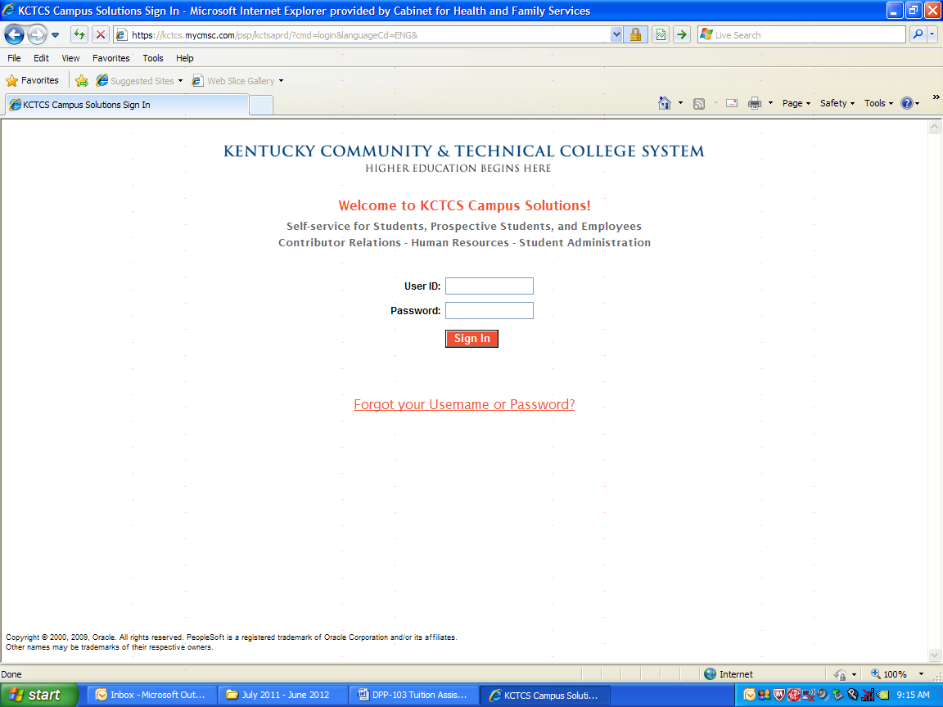

Below is a screen shot of the Murray State University myGate website.

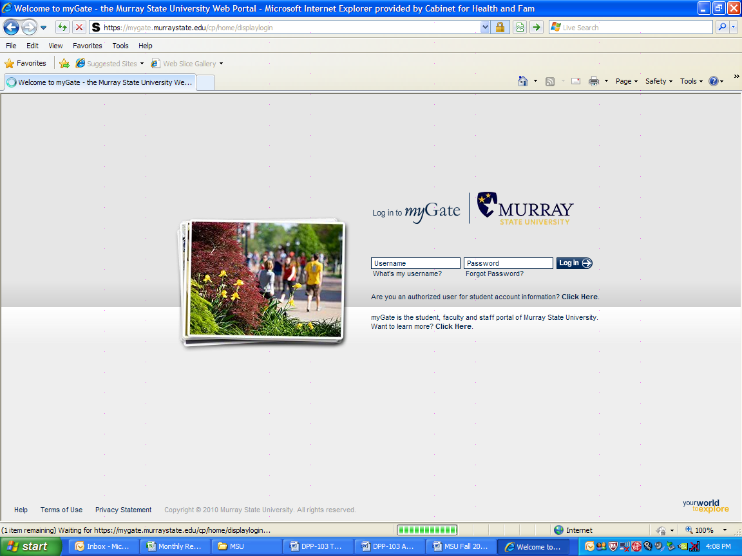

Below is an example from a student’s myGate account at Murray State University. It lists all of the youth’s expenses for the Fall Semester and financial aid resources. In this example, the youth still owes $14.32.

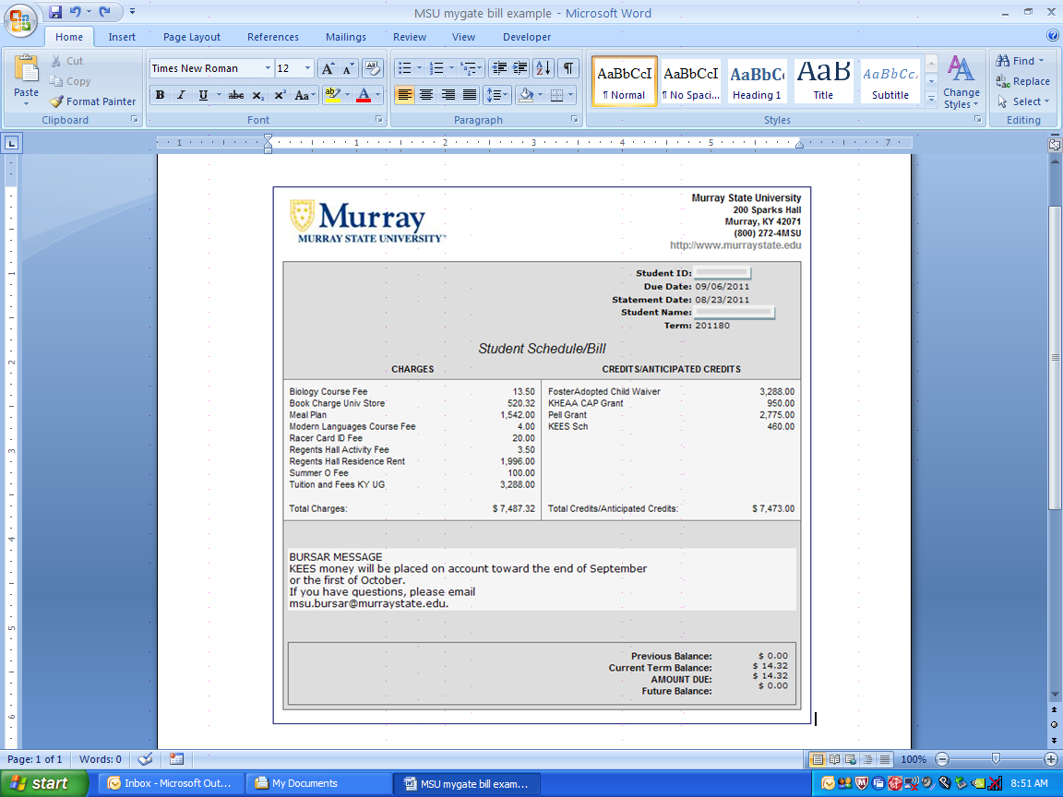

**Step 2: Completion of DPP-103 Application for Tuition Assistance**

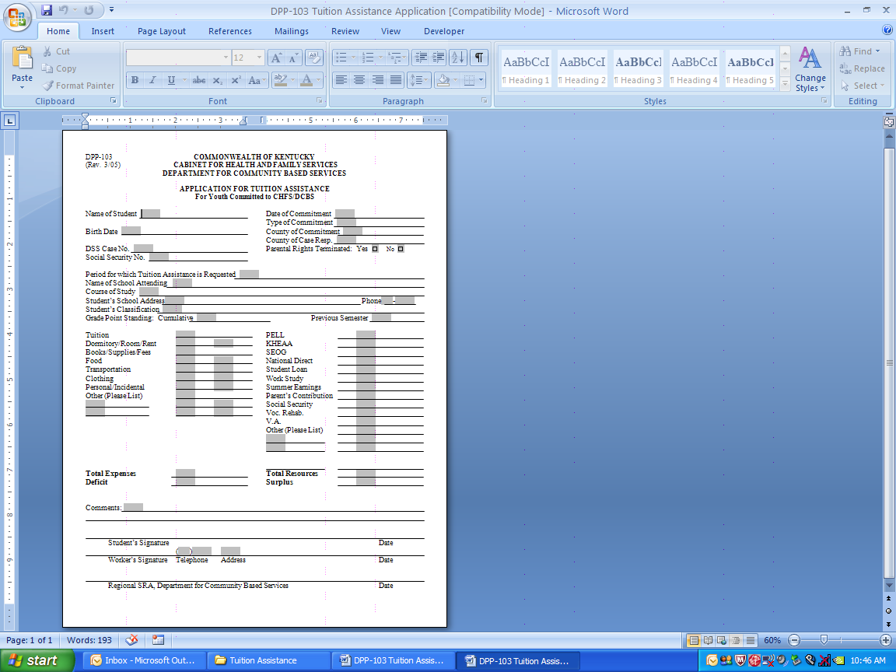

Explain how much is owed & who will receive payment.

Youth’s signature

Financial

Aid Resources

School

Expenses

Youth

Info.

Youth

Info.

Worker’s signature & contact info.

SRA Approval signature

**Tuition Assistance Deficit Example:**

List all resources & financial aid

List all school expenses

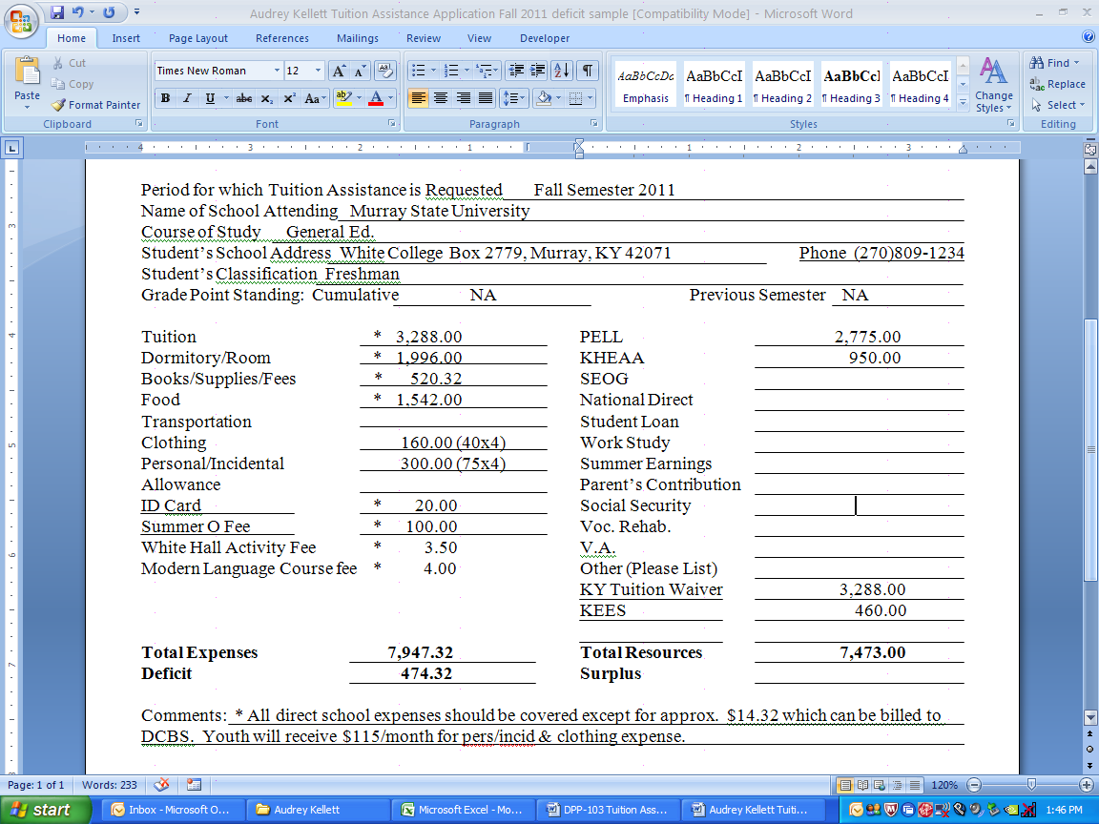

In the above example, the Cabinet will need to pay approximately **$14.32** to Murray State University and the youth will receive $115/month for clothing/personal/incidentals or $460 in one lump sum. A worker should consider the youth’s maturity level on whether monthly installments or one lump sum is more appropriate.

**Sample Letter to Bursar Office**

Below is an example of a letter to send to the college’s bursar’s office regarding expenses that the Cabinet may need to pay to the college. A copy of the tuition assistance approval should be submitted along with the memo.

* Make sure you include on the memo to the Bursar Office your contact info. (DCBS Office mailing address, phone #, & email address).
* **Sending the college notification is important because if arrangements have not been made by the payment deadline, the youth’s classes can be purged/dropped.**

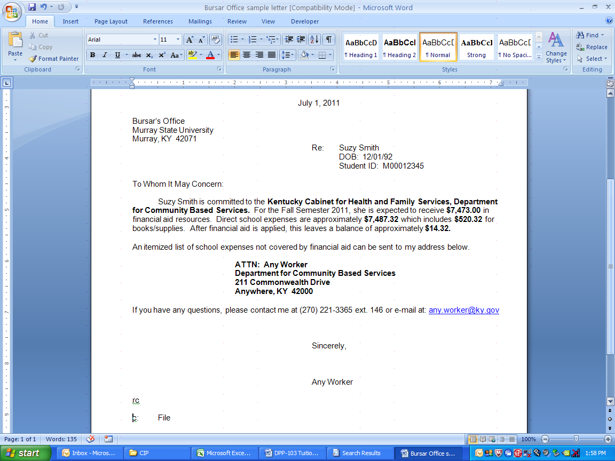

**Tuition Assistance Surplus Example:**

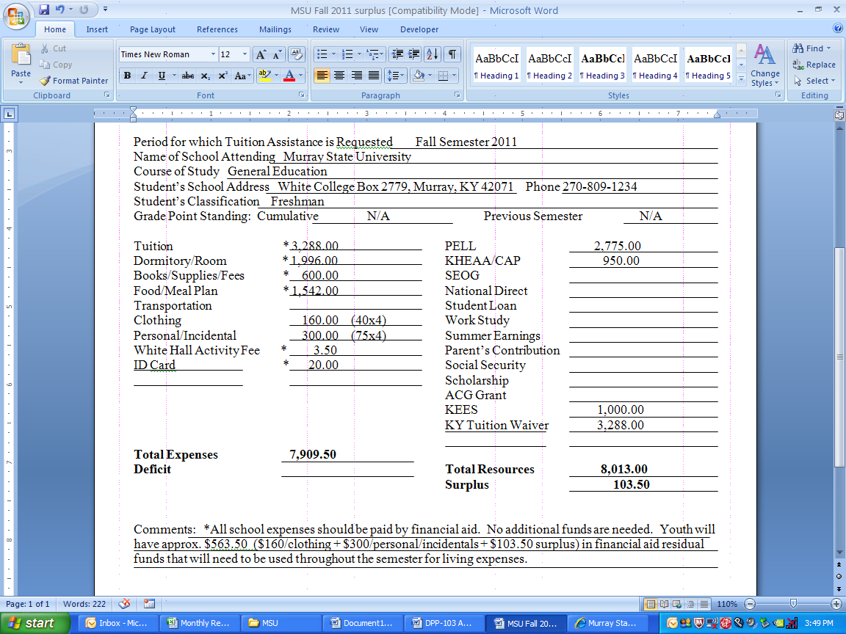

If a youth has a surplus like the above example, then nothing else needs to be done. No additional approval is needed nor does anything need to be submitted to the Regional Billing Specialist. The youth above will have approx. $563.50 after financial aid is applied to spend throughout the semester. This figure is obtained from adding the surplus amount ($103.50) plus the non school related expenses of clothing ($160.00) and personal/incidental expenses ($300.00). It is a good idea to meet with the youth at least a month prior to classes beginning each semester to make sure no additional funds will be needed for the semester.

**Remember, a youth attending college should also have a part-time job.** Work-study jobs on campus are highly recommended but if none are available or the youth waited too late to sign up for work-study, the youth will have to find an off campus job to meet the work requirement.

**Step 3: Payment of Tuition Assistance Funds**

**Payment directly to the Youth:**

When submitting tuition assistance payments to the Regional Billing Specialist, an email like the below example should suffice. In this example the youth is receiving $115/month ($40 - clothing and $75 - personal/incidentals). If paid in monthly installments instead of one lump sum, it is recommended to add a reminder to your Outlook calendar so you will not forget to submit payment info. to the Regional Billing Specialist.



**Payment to the college:**

If a memo along with a copy of the tuition assistance approval was sent to the college’s bursar office stating you expect money will still be owed to the college after financial aid is applied, the college may send you a billing statement/invoice. If an invoice is not mailed, you can log on to the student’s account to access the amount that is still owed, print it out and give this to the Regional Billing Specialist for payment to the college.

Each state college should already be set up in TWIST as a vendor for such payments. If not, a vendor request form will need to be completed and submitted before payment can be issued.