The Department for Behavioral Health, Developmental and Intellectual Disabilities has created a website that can assist staff in locating crisis stabilization programs for children. This website is updated in real time to ensure that all providers and contact information remains current.
Please click on this link: Online Provider Directory to access a list of crisis stabilization programs in your area.
The link will direct the user to the following page:
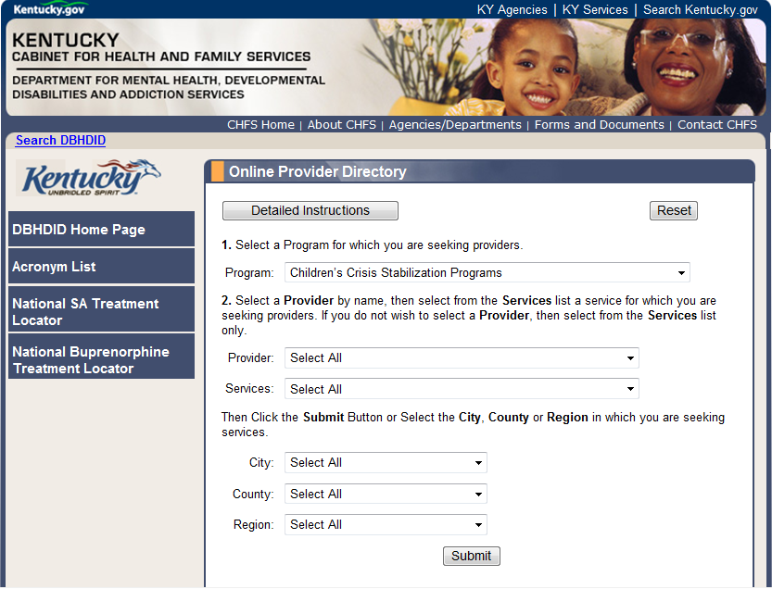

Complete the information on the screen to obtain a list of programs in your area.

